# Group and Members:

Folk Detect Innovative Bison

Ian Hays

Xavier Beynon

Ashley Ng

Riley Gibson

# Methods:

A number of different methods to get the route tape were attempted, such as feature detection using SIFT (figure 2), edge detection using Canny (figure 1) to get the outline of the tape, and using a threshold (figure 3).

Our current implementation converts the color space to HLS, using a combination of the saturation and luminosity channel to identify neon colored tapes as well as applying a threshold (figure 3). From the threshold image, we draw bounding boxes around the tapes by using contour detection and saving the top left and bottom right points to a file in JSON format. We then get the ground truth of the locations of the tape using the bounding box tools that were created in the directory ground truth. From there we test the accuracy of our calculated boxes around the tape and our ground truth boxes. We do this by using an algorithm to test the overlap of these squares, and make sure that the overlapped area is of a certain size. We finally get our accuracy by comparing the number of boxes in the ground truth versus the number that were deemed true positives by the overlapped area. The best accuracy we obtain is a 91.1% accuracy. Images of our calculated boxes and true positives can be seen in figures 4 and 5 respectively.

For our next objective of programmatically identifying the tape by colors, we then find contours to outline the tape shapes and average the pixels inside to categorize the tape (blue route, orange route, etc). Currently developing heuristics to minimize false positive tapes detected. We were not able to make an accuracy check for identifying the tape by color in the time permitted for progress report 2

# Results:

For our initial attempts, we used the panoramic we created of the smaller wall (smallPano.jpg), in some cases we did change the size of the image for ease of testing. It may be hard to see some of the features or edges in the following figures, but all the original images can be seen in the images/routeDetection directory. The JSON files of our groundtruth points and calculated points can be seen in the directories groundtruth/groundtruth.txt and accuracyCheck/calculated.txt directories respectively

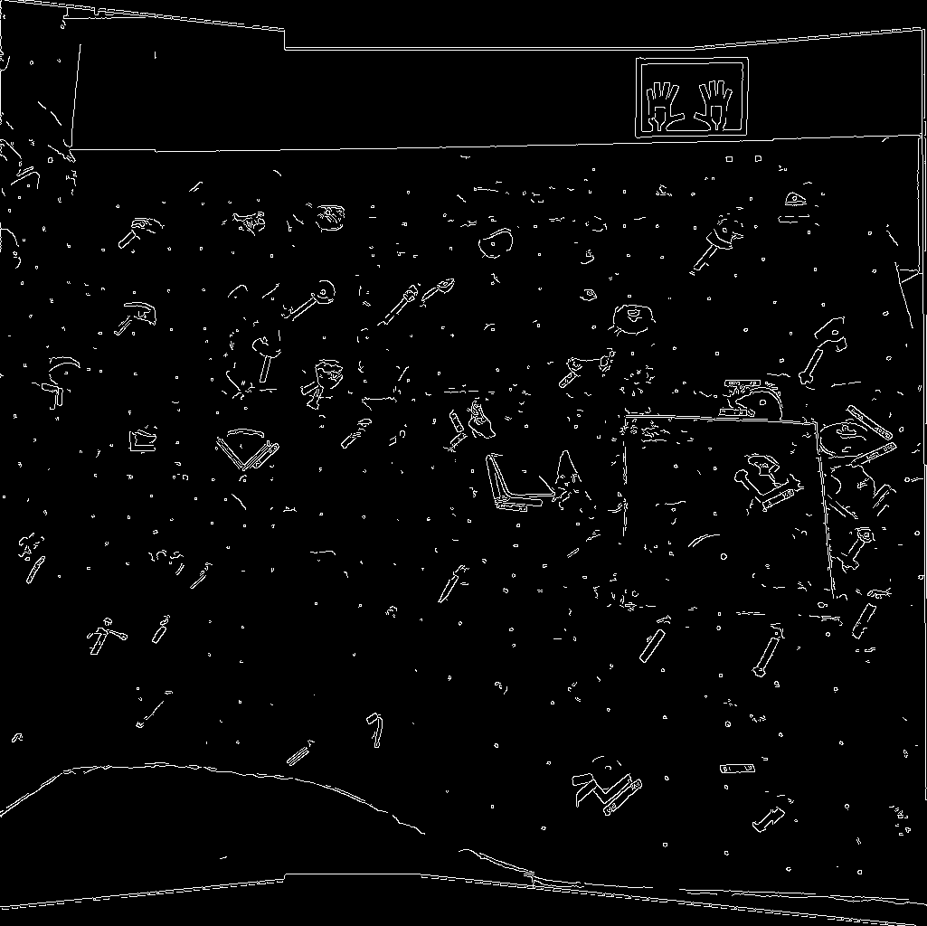

Figure : Canny Edges

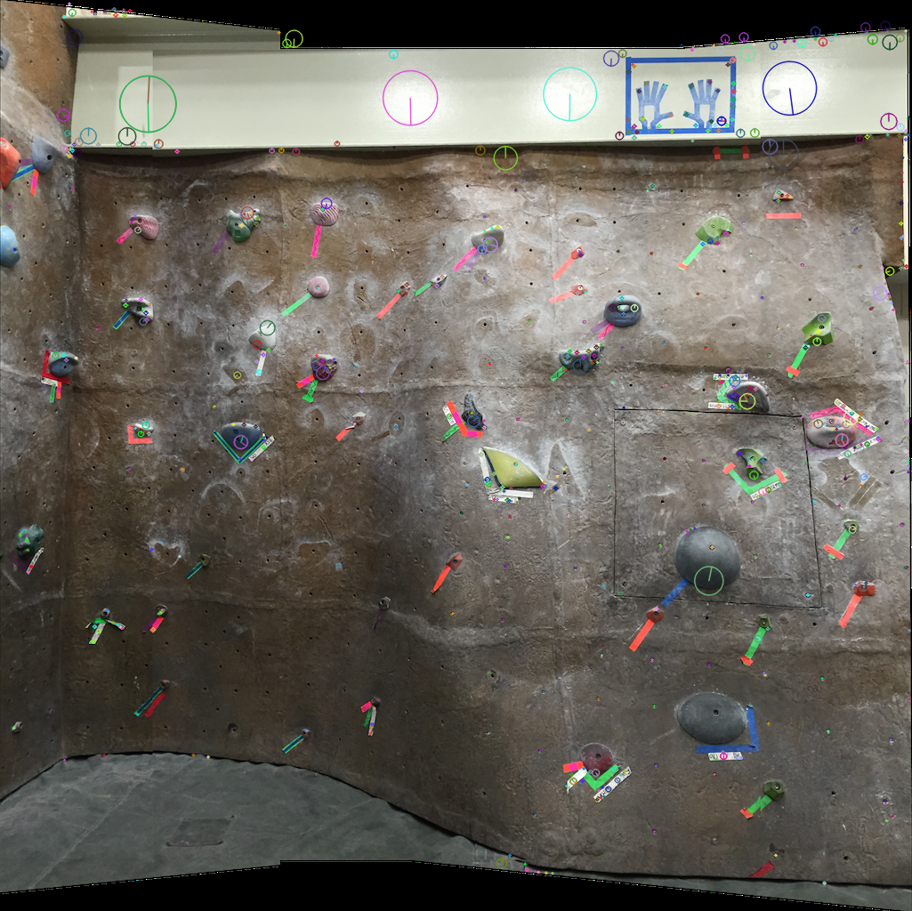

Figure : SIFT Feature detection

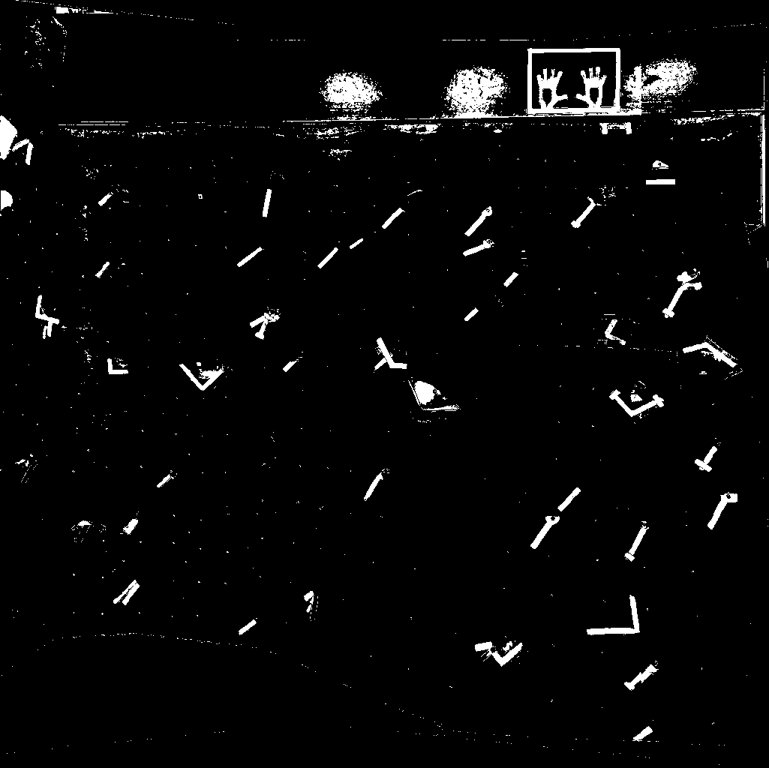

Figure : Threshold of image

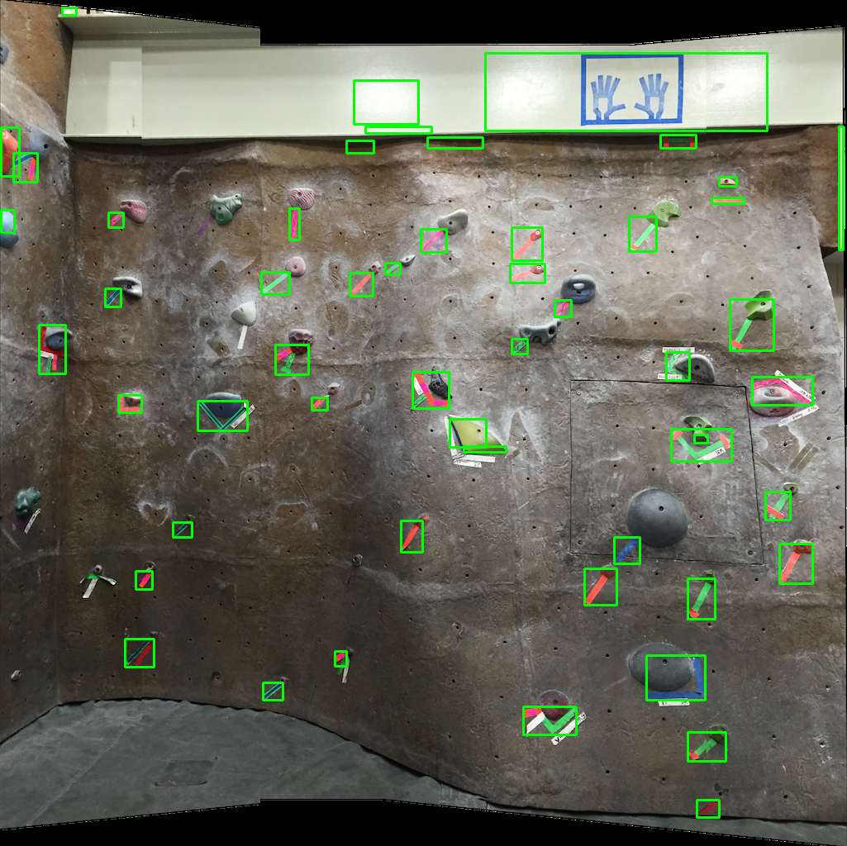

Figure : Programmatically detected bounding boxes

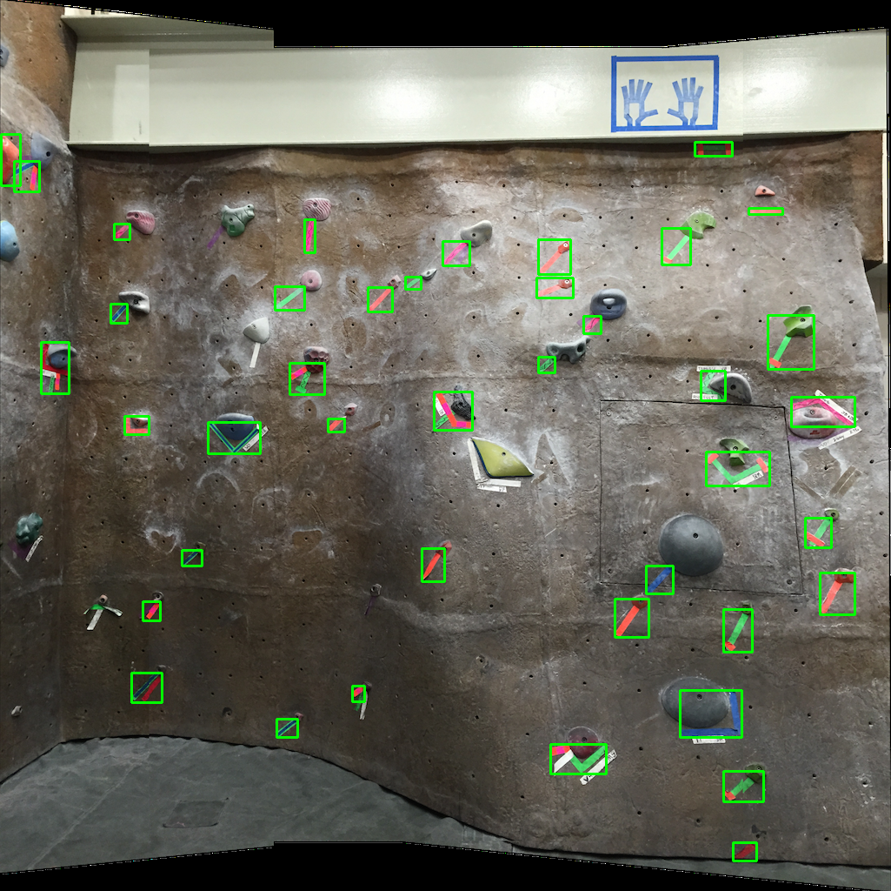

Figure : True positives from accuracy check

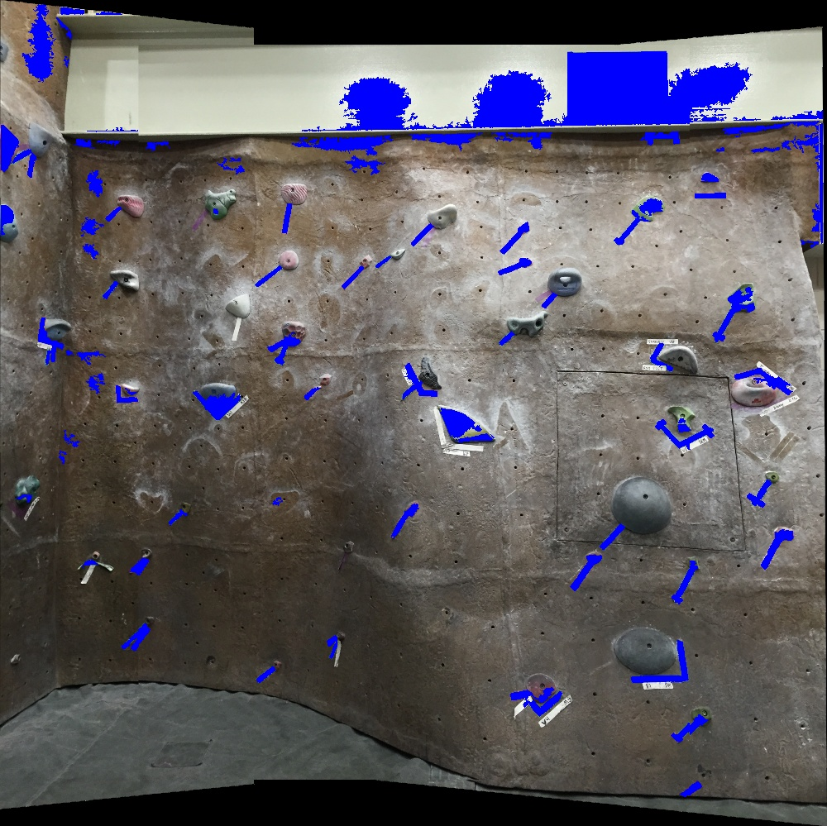

Figure : Detect tapes (with some false positives)

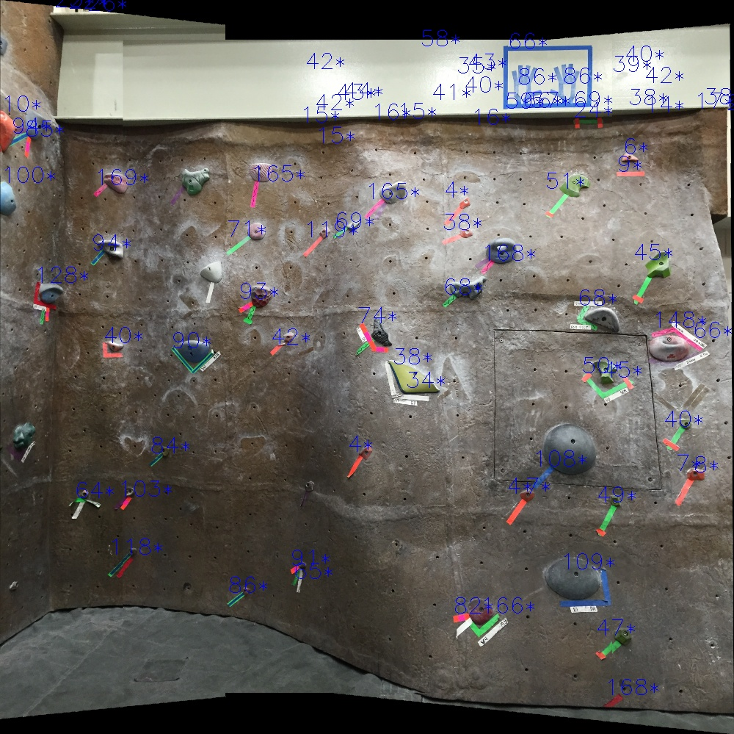

Figure : Average hue value(tape color) of detected tapes